
Company
Logotype

Cone Beam Computed Tomography- Report



Porur Dental X-rays & CBCT

Patient Name : Master. Rudhran Sai | Date of Report : 19.07.2025
Age/ Gender : 8 years/ Male | Region of Interest : CBCT Sectional Maxilla
Referring doctor: Dr. Selva Ganesh | Indication : Mesiodens irt 11, 21
Clinical Notes: Nil
PATIENT INFORMATION

CBCT- Sectional Maxilla provided
CBCT – IMAGE DETAILS

RADIOGRAPHIC INTERPRETATION

- No of teeth present in the field of view: 11, 12, 21, 22
- Deciduous teeth: 53, 54, 55, 63, 64;
- Permanent Successors: 13, 14, 15, 23, 24 present above the deciduous teeth.
- The teeth 11, 21 are present with open apices.
- In relation to the palatal aspect of 21, presence of an additional tooth structure (with normal morphological features of crown and root) that appears to be located in close proximity to the tooth 21.
- The impacted tooth structure appears to be positioned in inverted manner, likely of conical shape with its root portion lodging below the cingulum of 21.
- Distance between the palatal cortical bone and impacted tooth: 0.87 mm
- The maxillary alveolar ridge is present with normal trabecular pattern.

RADIOGRAPHIC IMPRESSION

- Impacted and inverted supernumerary tooth: palatal to 21.
- Permanent Successors: 13, 14, 15, 23, 24

Kindly correlate with clinical findings


IMAGES FOR REFERENCE

RECONSTRUCTED PANORAMIC VIEW

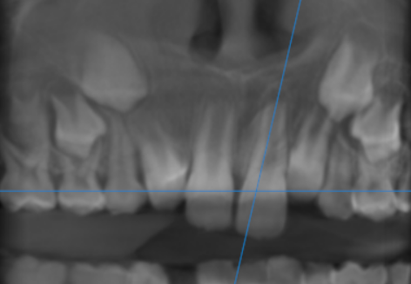

AXIAL VIEW
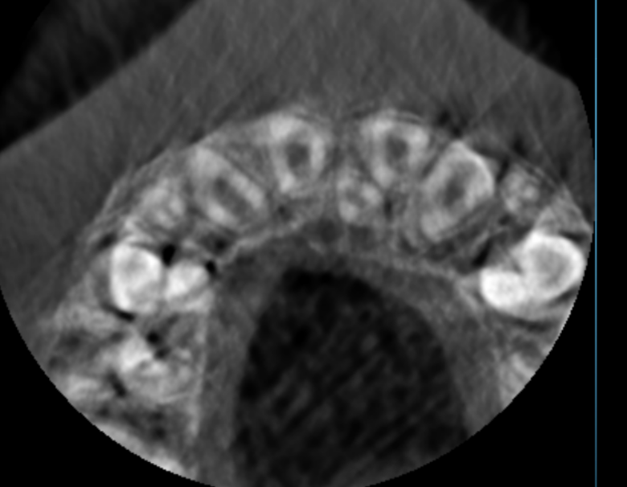

3-DIMENSIONAL VIEW (labial view)

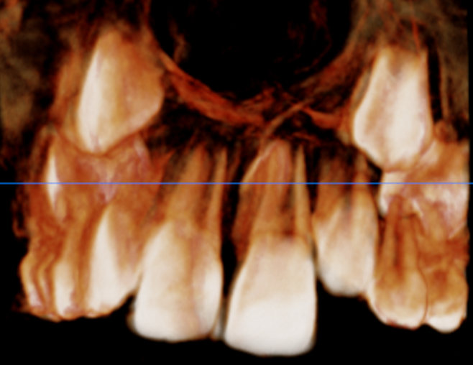

3-DIMENSIONAL VIEW (palatal view)

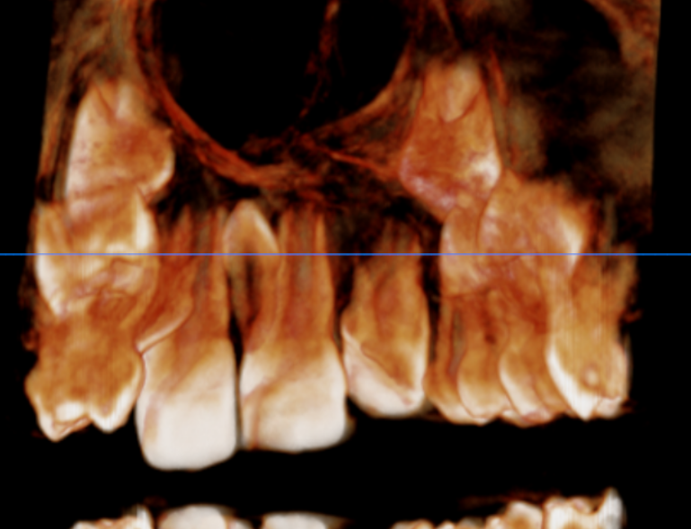

CROSS SECTIONAL VIEW

21 region | 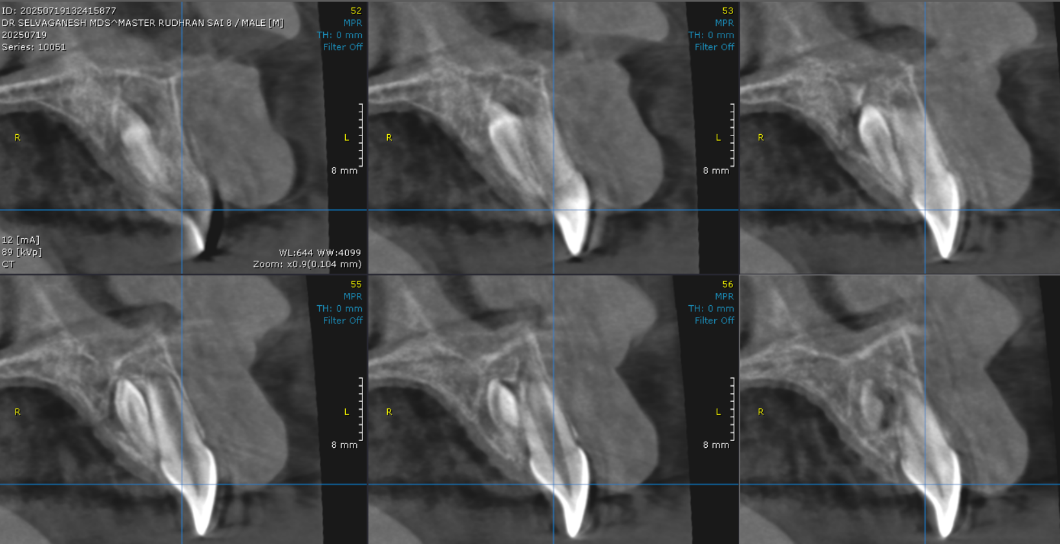
Position of 21 and the impacted supernumerary tooth | 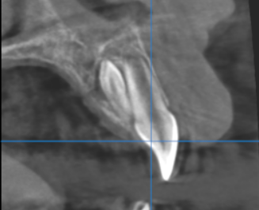

**** End of report ****

